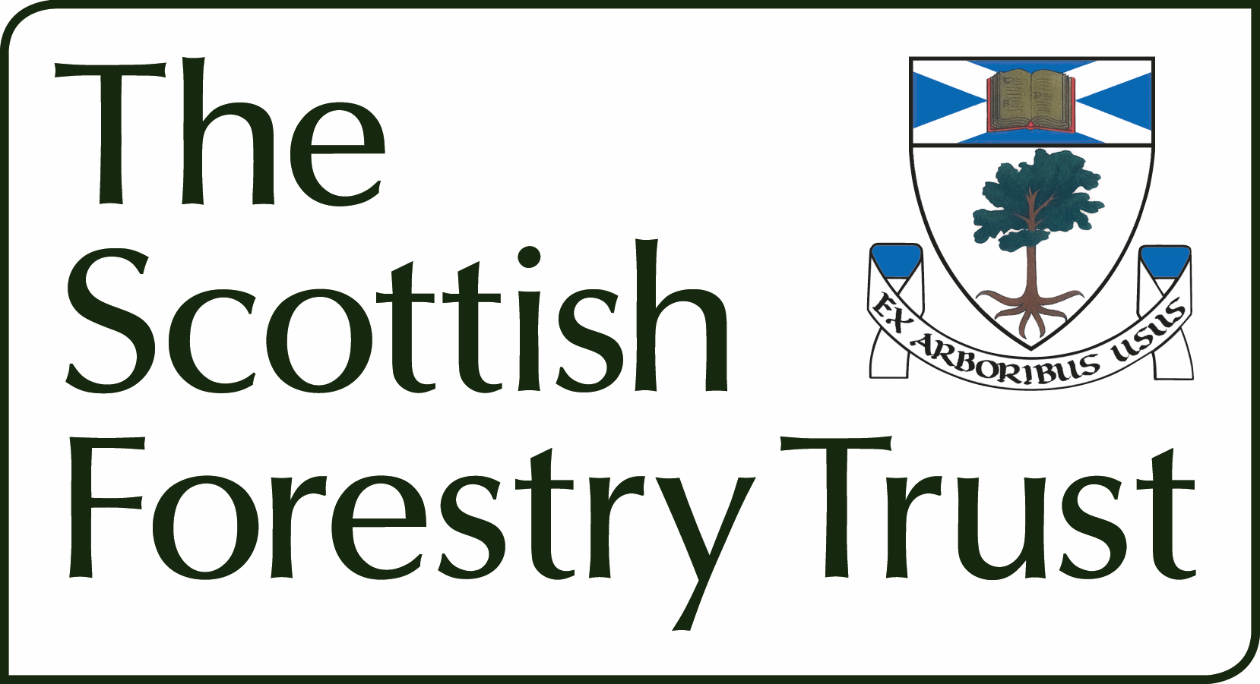

Application Form

Support for Early Researchers Conference Attendance Fund

Name, date and location of the Conference (maximum 50 characters)

Names and roles of prospective attendees (maximum 3 attendees per event). Please also indicate date of PhD Award (or graduation for non-doctoral applicants).

Short description of the objectives of the conference (maximum 300 words)

Explain how attending the conference will provide opportunities to present and/or strengthen future collaboration and networking for the attendees and what benefits they hope to bring through attending to a) the organisation and b) their future role in UK forestry (maximum 300 words)

Funding
 | £ | %
The Scottish Forestry Trust
Other sources (please specify)
Total |  | 100
Is Match Funding Confirmed |  | Yes/No
Name of applicant

Institution / organisation

Address of applicant

Tel.
Email:

Signature of applicant*

Date:

*Please ensure you have read and complied with the guidance notes for this scheme.

The completed form should be sent to director@scottishforestrytrust.org.uk We will aim to give a decision on your application within 4 weeks of receipt of your application.

